# Assignment-4

|  |  |
| --- | --- |
| StudentName | M.manojiraj |
| RegisterNumber | 810419106006 |
| ProjectName | SmartFarmer- IoTEnabledSmartFarmingApplication |

**Question-1:**

Write code and connections in wokwi for the ultrasonic sensor. Whenever the distance is lessthan100cmssend an"alert"totheIBMcloud and displayin thedevicerecentevents.

Uploaddocument withwokwi sharelinkand imagesofIBM cloud.

# CODE:

#include<WiFi.h>#include<PubSubClient.h>

void callback(char* subscribetopic, byte* payload, unsigned intpayloadLength);

#defineORG"49x4b9"#define DEVICE_TYPE "esp32"#defineDEVICE_ID"97043"

#defineTOKEN"7993276080"

Stringdata3;

char server[] = ORG ".messaging.internetofthings.ibmcloud.com";charpublishTopic[]= "iot-2/evt/Data/fmt/json";

char subscribetopic[] = "iot-2/cmd/test/fmt/String";charauthMethod[]="use-token-auth";

chartoken[]=TOKEN;

charclientId[]="d:"ORG":"DEVICE_TYPE":"DEVICE_ID;

WiFiClientwifiClient;

PubSubClient client(server, 1883, callback ,wifiClient);constinttrigPin= 5;

const int echoPin = 18;#define SOUND_SPEED 0.034longduration;

float distance;voidsetup(){

**Serial**.begin(115200);pinMode(trigPin, OUTPUT);pinMode(echoPin, INPUT);wificonnect();mqttconnect();

}

voidloop()

{

digitalWrite(trigPin, LOW);delayMicroseconds(2);digitalWrite(trigPin, HIGH);delayMicroseconds(10);digitalWrite(trigPin, LOW);duration=pulseIn(echoPin,HIGH);

distance = duration * SOUND_SPEED/2;**Serial**.print("Distance (cm): ");**Serial**.println(distance);if(distance<100)

{

**Serial**.println("ALERT!!");delay(1000);PublishData(distance);delay(1000);

if (!client.loop()) {mqttconnect();

}

}

delay(1000);

}

void PublishData(float dist) {mqttconnect();

String payload = "{\"Distance\":";payload+=dist;

payload += ",\"ALERT!!\":""\"Distance less than 100cms\"";payload+="}";

**Serial**.print("Sendingpayload:");

**Serial**.println(payload);

if(client.publish(publishTopic,(char*)payload.c_str())){

**Serial**.println("Publishok");

}else{

**Serial**.println("Publishfailed");

}

}

voidmqttconnect(){

if (!client.connected()) {**Serial**.print("Reconnecting client to ");**Serial**.println(server);

while(!!!client.connect(clientId,authMethod,token)){

**Serial**.print(".");delay(500);

}

initManagedDevice();

**Serial**.println();

}

}

voidwificonnect()

{

**Serial**.println();**Serial**.print("Connecting to ");WiFi.begin("Wokwi-GUEST","",6);while(WiFi.status()!=WL_CONNECTED){delay(500);

**Serial**.print(".");

}

**Serial**.println("");**Serial**.println("WiFi connected");**Serial**.println("IP address: ");**Serial**.println(WiFi.localIP());

}

voidinitManagedDevice(){

if (client.subscribe(subscribetopic)) {**Serial**.println((subscribetopic));**Serial**.println("subscribetocmdOK");

}else{

**Serial**.println("subscribetocmdFAILED");

}

}

voidcallback(char*subscribetopic,byte*payload,unsignedintpayloadLength)

{

**Serial**.print("callbackinvokedfortopic:");

**Serial**.println(subscribetopic);

for(inti= 0;i<payloadLength;i++)

{

data3+=(char)payload[i];

}

**Serial**.println("data: "+ data3);data3="";

}

**WokwiLink:<https://wokwi.com/projects/347310895770108498>**

Outputand Simulation :

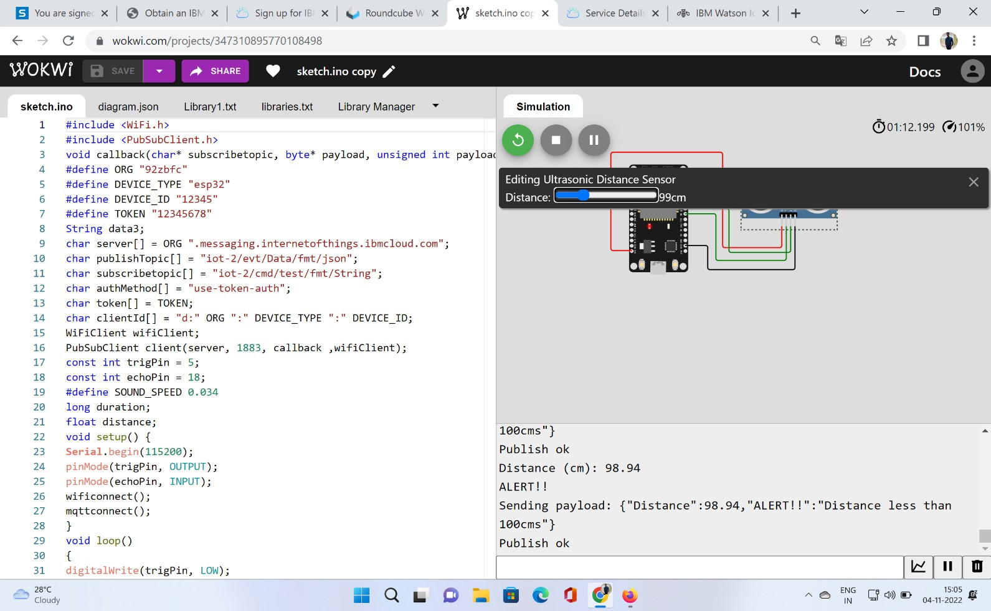

Wheneverthedistanceisless than100cmssend an"alert"totheIBMcloudanddisplayinthedevicerecent events.

